Civil war in Somalia

UNSC Resolution: | 767
Date of adoption: | 24-Jul-1992
Operative paragraph: | 3
Demand number: | 767,0311

Sarah-Myriam Martin-Brûlé

Wording of demand
- facilitate the efforts of the United Nations, its specialized agencies and humanitarian organizations to provide urgent humanitarian assistance to the affected population in Somalia and reiterates its call for the full respect of the security and safety of the personnel of the humanitarian organizations and the guarantee of their complete freedom of movement in and around Mogadishu and other parts of Somalia

List of addressees of the demand
- Government of Somalia, United Somali Congress Faction

Short-term compliance

Description of the addressee(s)’ conduct

“Since the airfield in interior cities like Baidoa and Bardera were unprotected, the local militia quickly adopted the practice of extorting landing fees and looting.”

John Hirsh & Robert B. Oakley. 1995. Somalia and Operation Restore Hope: Reflections on Peacemaking and Peacekeeping. USIP. P. 24.

“General Mohamed Farah Aideed, leader of the Somali National Alliance, and one faction of the United Somali Congress (USC), had frustrated the United Nations and had made UNOSOM I ineffective by restricting the deployment of the UN Pakistani troops to the airport. Lyons & Samatar, p.39.

Terence Lyons & Ahmed I. Samatar. 1995 “Somalia: State Collapse, Multilateral Intervention and Strategies for Political Reconstruction. Brookings Institution. Occasional Paper. Washington D.C.

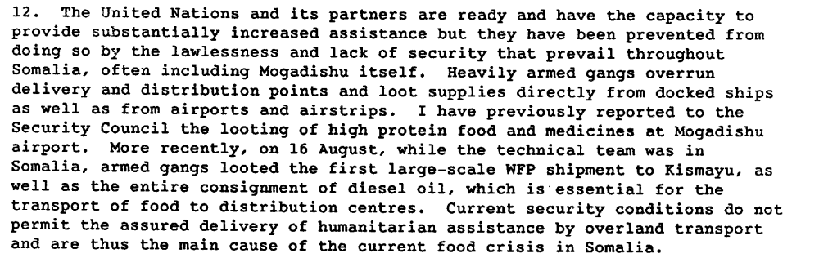

Report of the Secretary-General on the Situation in Somalia, S/24480, 24 August 1992

(...) the situation in Somalia continued to deteriorate through October and
November 1992. Mr. Ismat Kittani from Iraq took over as the new SRSG. The security
situation was most complex at the time. Besides the increased faction rivalries,
widespread looting of aid supplies, robbery, armed banditry, and general lawlessness
marred the humanitarian relief. Various factions openly challenged the shipping,
convoying, and distribution of supplies. Troops were being fired upon. Amidst such
complexities very little of the aid was reaching the people in need.58

Abul Fazal MD Sanullah. 2002. United Nations’ Operation in Somalia: The Possiblity of Success with a Different Approach or Application.
http://www.dtic.mil/cgibin/GetTRDoc?AD=ADA406495&Location=U2&doc=GetTRDoc.pdf

The situation in southern Somalia continued to deteriorate. Looting increased significantly (…) the percentage actually reaching people in dire need fell by 40%.

John Hirsh & Robert B. Oakley. 1995. Somalia and Operation Restore Hope: Reflections on Peacemaking and Peacekeeping. USIP. P. 25

Assessment

Short-term compliance
X No or marginal compliance (1) | Medium low compliance (2) | Medium high compliance (3) | Full or almost full compliance (4)

Considerations underlying the assessment

Within the six months following the adoption of the resolution, the demand addressees impeded the efforts of the United Nations, its specialized agencies and humanitarian organizations to provide urgent humanitarian assistance to the affected population in Somalia. They did not respect the security and safety of the personnel of the humanitarian organizations and impeded their movement in and around Mogadishu and other parts of Somalia.

Medium-term compliance

Description of the addressee(s)’ conduct

A proposal for dividing Somalia into four zones was endorsed in UNSCR 767 on 27 July 1992, although not effectively followed up as far as deployment and aid are concerned. Meanwhile, the concern for prevalent fighting over food was high. As the situation deteriorated, the Secretary-General proposed enhanced involvement by the UN and recommended further assessment by a technical team.

Abul Fazal MD Sanullah. 2002. United Nations’ Operation in Somalia: The Possiblity of Success with a Different Approach or Application.
http://www.dtic.mil/cgibin/GetTRDoc?AD=ADA406495&Location=U2&doc=GetTRDoc.pdf

“During the harbor visit, artillery fire targeting the docking facilities came from the Mahdi position. Aidid informed Johnston that the fire was just “Mahdi sending a message”. Afterward, he learned that three shells fired by Mahdi’s forces had hit a relief ship carrying eleven tons of wheat, forcing it to return to Mombassa.”

“The meetings all ended with the same conclusion about Somalia: militias and their warlord leaders would not work with peacekeepers to facilitate food deliveries. In fact, the militias would continue to loot the humanitarian aid unless faced with forceful opposition”.

“(…) negotiations between the UN and the Somali warlords continued to be meaningless. For example, on November 23 Mahdi promised the UN that he would open Mogadishu’s port to allow food aid ships to dock. Yet the following day, a World Food Program ship was shelled by his forces as it attempted to enter the harbor.”

Kenneth Rutherford. 2008. Humanitarianism Under Fire: The US and UN Intervention in Somalia. Kumarian Press, p. 70-71.

The technical team had evaluated the possible extension of the ceasefire activities of UNOSOM at Mogadishu to other parts of the country. However, concern had been
expressed by several regional leaders about the implications of such an operation for the balance of military forces within the country. Given that attitude, the lack of an effective ceasefire and the fluidity of the fighting, the Secretary-General concluded that it was
not feasible to deploy military observers outside Mogadishu.

Repertoire of the Security Council, 1989-1992, The Situation in Somalia

http://www.un.org/Depts/dpa//repertoire/89-92/CHAPTER%208/AFRICA/item%2006_Somalia_.pdf

Assessment

Medium-term compliance
X No or marginal compliance (1) | Medium low compliance (2) | Medium high compliance (3) | Full or almost full compliance (4)

Considerations underlying the assessment

Within the two years following the adoption of the resolution, the demand addressees did not facilitate the efforts of the United Nations, its specialized agencies and humanitarian organizations to provide urgent humanitarian assistance to the affected population in Somalia. The demand addresses did not respect of the security and safety of the personnel of the humanitarian organizations and they impeded of their movement in and around Mogadishu and other parts of Somalia

Depth of demand

Assessment

Level of depth of demand
Low depth of demand (1) | X Medium depth of demand (2) | High depth of demand (3)

Considerations underlying the assessment

Looting was a way for the demand addressees to gain revenues/power. Compliance with this demand made it more for the demand addressees to attain victory in the civil war or to win power in its aftermath.

“Historical experience— the competitive rent-seeking of the Somali Republic and the open kleptocracy of the Barre dictatorship—has taught the Somalis that government is primarily a tool of economic gain for those in power.45 It is for this reason that fighting in Mogadishu has been so fierce: control over the capital is essential to establish a credible claim to the entire country’s government. The warlords have extended their depredations to other areas of southern Somalia to the extent that control of these areas yields resources that can be used in the battle over Mogadishu. Thus, Aideed’s forces have time and again threatened and captured the major port of Kismayo, with its lucrative trade. The farmlands of the Rahanweyn have been expropriated to pay off soldiers in the warlords’ armies. Control of strategic roads, air strips, and harbors has been hotly contested”

Sorens, Jason P. And Leonard Wantchekon. Social Order without the State: The Case of Somalia
http://www.somali-jna.org/downloads/Social%20Order%20without%20the%20State%20Somalis.pdf

Level of confidence about coding decisions

Level of confidence about coding decision
Extremely high | X High | Moderate

Comments to IPI (if any)

